Installing APA 7th edition Styles

- Click the link below to download the APA 7th edition style from EndNote webpage
- > EndNote_APA_7e Style
- Double-click the style file. It should open in EndNote.

- In EndNote, go to “File” and choose “Save As”. Provide your style’s name and click “Save”
(For example, you could save it as “APA 7th ed”)

- “Select Another Style” in pull down menu, find “APA7th ed”, then click “Choose”

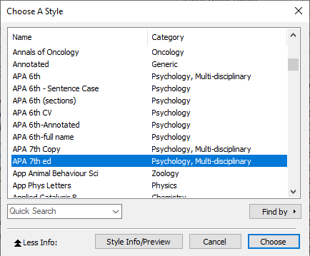

- Now you can select APA7th edition style in the pull down menu.

Select and Output Your EndNote Style

- Open your document in MS Word, click on the output style in the toolbar

- Click on “Select Another Style…”

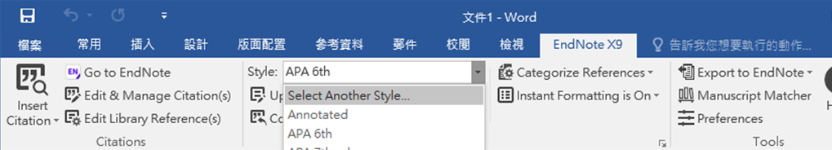

3. From drop down list, select your newly saved style, e.g. APA 7th ed
